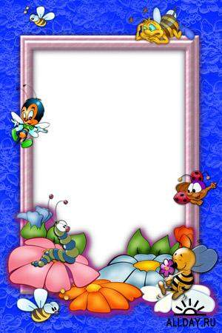

A Funny Party
“FOOD AND COOKERY”

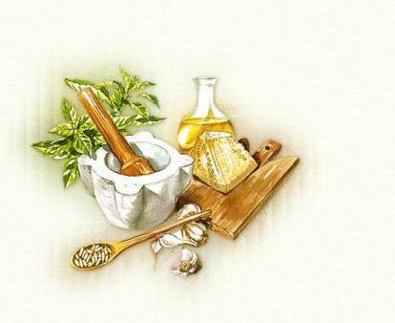
Мета:
- Активізувати слова по темі.
- Вивчити скоромовки.
- Тренуватись у перекладі віршів.
- Навчитись складати рекламу ресторану.
- Повторити англійські прислів’я по темі.
- Виховувати поважне ставлення до товаришів,працюючи в групах.
Обладнання:
картки з віршами та скоромовками; папір; малюнки для реклами; олівці.
Хід заняття:
- Good evening, dear friend!
I am very glad to see all of you in my classroom. I hope that people who really love English have gathered here. And today we shall have an English party devoted to food and cookery.
It is not a secret that Ukrainian people are big eaters. Our women cook very much and they cook tasty. But our men like to eat what our women cook and they are thankful for tasty dishes. There is even a saying about that: “Шлях до серця чоловіка лежить через його шлунок.” ( A way to the man’s heart is through his stomach). And there is another statement that the best chefs in the restaurants are men. And today we shall invite two teams (a team of boys and a team of girls) to take part in the competition and we shall see what statement is right.
- Let’s welcome our teams.
- And our competition will be judged by the jury. They are the pupils of the 11th form.
- At the beginning let’s have some kind warming up. I propose you to tell us all kinds of food that you know. Who is the last, will be the winner.
- So, we have recalled all necessary words but before speaking let’s train our tongue. We will read tongue-twisters. (two tongue-twisters for every team)
*** Can you can a can as a canner can can a can?
***
How many cookies could a good cook cook if a good cook could cook cookies? A good cook could cook as much cookies as a good cook who could cook cookies.
- While our teams are preparing the task we will work with our audience. We will play a game ” Yes or No.” I’ll read the sentences and if they are false correct them.
- Lobster is a kind of fruit.
- Salad is usually a mixture of uncooked vegetables.
- Oil and vinegar are often used with a green salad.
- Peas, broccoli, cucumbers and lemons are all the same colour.
- Vegetarians do not eat meat.
- You eat soup and pasta with a fork.
- English people are great coffee-lovers.
- Borsch is the first course.
- Shrimps or prawns live in the sea.
- McDonalds is a fast food restaurant.
- To loose a weight you should eat sweets.
- Cherry is a berry.
- You eat two times a day.
- Ukrainian people eat borsch with sour-cream and garlic.
- We bake pies in the oven.
- Look! I have a magic box. There is something in it. Try to guess what it is there. (Is it …?)
- Yes you are right. It is a potato. And look at this advertisement. It is an advertisement of a restaurant called “ Potato Paradise”. I think that all dishes in the menu are cooked with potato. Imagine that you are chefs of that restaurant and your task is to write down dishes which contain potato.
- Work with the audience. Let’s guess.
*** Clean, but not water;
White, but not snow;
Sweet, but not honey.
What is it?(milk)
*** When I eat, I live; but when I drink, I die. What am I? (fire)
*** A room which we can eat?(mushroom)
*** Question: You throw away the outside and cook the inside. Then you eat the outside and throw away the inside. What did you eat?
(Corn on the cob: You throw away the skin or sheaf, then cook it, eat the corn, then throw away the cob.)

- I see that you are very creative and you can open your own restaurant. But before opening make an advertisement of your restaurant. You can use paper, pictures, pencils from the table for your work.
- While our teams are preparing the task we will play a game “crocodile”.
Show us … ( a cabbage, a pan, a mixer, a knife, shish kebab, a birthday cake)
- And now advertise your restaurants.
- As we see that there will not be only potato dishes but with other products too. Your next task will be to match the words on the left with the definitions on the right.
- Bitter a. a lot of sugar
- Sour b. rather negative, very little flavour
- Hot, spicy c. no flavour at all
- Sweet d.has a good taste, flavour
- Salty e. e.g. a strong Indian curry
- Sugary f. a lot of salt
- Tasty g. sharp, unpleasant
- Tasteless h. like a beautiful, ripe strawberry

- Sometimes very funny thing can happen in the restaurant. Look at the
picture. It is funny, isn’t it? It happened in one of the restaurant. Your task is to make up a story. But your story must contain one word, one word-combination, or one sentence to reproduce the feeling of the visitor.
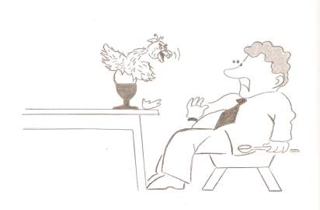
- Food is one of the important part of our life. Food can be found everywhere. But where exactly… Let’s try to translate the poem “A Food For Everything.”
A FOOD FOR EVERYTHING!
Meals are the food for the body;
Knowledge is the food for the mind;
Meditation is the food for the spirit;
Music is the food for the love of heart;
Dreams are the food for the consciousness;
Prayer is the food for the Almighty;
Love is the food for the living heart;
Thoughts are the food for the brain;
Colourful ink is the food for the pen;
Ideas are the food for the stories;
Truth is the food for the will;
Sun’s energy is the food for the plants;
Plants are the food for the living beings;
But one man’s food is another man’s poison!
16.Let’s sing a song.”Peel banana”.

