Сценарій святкової розваги “Halloween”

Мета: познайомити учнів з традиціями святкування, формувати навички спілкування за темою, розвивати творче мислення, вміння працювати в групі

Клас заздалегідь необхідно розділити на дві команди та обрати журі конкурсу.

(Слайд 1)

(Перегляд відео з привітанням до свята).

(Слайд 2)

Ведучий: Hello, dear guests and pupils! It’s nice to see you today. I have some questions for you. Do you like to celebrate festivals? What festivals do you know? Look at the symbols of our today’s festival and name it. Let’s read it together (всі вимовляють хором назву свята) – It’s Halloween!!! Yes, you are right.

Halloween began as an ancient Celtic festival in Great Britain and Ireland, and has survived most strongly among Irish, Scottish and Welsh communities. Immigrants from these communities carried the tradition to North America where it has gained in popularity. In turn, as part of American pop culture, Halloween has spread in popularity to most corners of the English speaking western world, and increasingly into Western Europe in recent times.
Originally Halloween was a pagan festival, around the idea of linking the living with the dead, when contact became possible between the spirits and the physical world, and magical things were more likely to happen. Like most pagan festivals, long ago it was absorbed into the festivals of the expanding Christian church, and became associated with All Hallows Day, or All Saints Day, which eventually fell on November 1 under the Gregorian calendar. A vigil for the festival was held on All Hallows Evening on October 31. In the vernacular of the times, All Hallows Evening became Hallowe'en and later the Halloween we know today.
According to old beliefs Halloween is the time, when the veil between the living and the dead is lifted, and witches, ghosts and other supernatural beings appear. Many Halloween customs are based on beliefs of the ancient Celts, who lived 2,000 years ago in what is now Great Britain, Ireland and Northern France. Every year the Celts celebrated the Druid festival of Samhain, Lord of the Dead and the Prince of Darkness. It fell on October 31, the eve of the Druid New year. The Celts believed that on this night Samhain allowed the souls of the dead to return to their homes as witches, goblins, black cats or in other weird forms. It was believed that evil spirits played tricks on October 31.

(Слайд 3)

(Перегляд відео з піснею This is Halloween.)

The main Halloween activity for children is trick-or-treating. They dress in costumes and masks and go from door to door saying “trick or treat”.
Trick or treat, smell our feet.
We want something good to eat.
The neighbors give children such treats as candy, fruit and pennies so that children do not play tricks on them.

(Слайд 4)

(Перегляд відео з піснею Trick or Treat.)

Jack-o-lanterns are pumpkins with face carved into one side. An Irish legend says that Jack-o-lanterns are named after the man called Jack. He could not enter the hell because he had played jokes on devil. As a result, Jack has to walk on the Earth with his lantern until Judgment Day.

(Слайд 5)

(Перегляд відео з піснею Singing Pumpkins.)
Fortunetelling is an important part of the Halloween. For example, you can bake a ring, a coin and a thimble in a cake. It was believed that the person who found the coin would become wealthy. The one who found a ring would merry soon, and the person who found a thimble would never get married. People also believed that there were many ghosts and witches on the Earth and they met on October 31st to worship the devil. Today people do not believe in ghosts, but they like to tell stories about them on Halloween.

І. Now you know a lot about Halloween and we invite you to start our fun. Our first competition is “Warm up”

(Слайд 6)

1. Match the words and their meanings.
1 | Ghost | A | Вампір
2 | Cauldron | B | Труна
3 | Haunted house | C | Дім з привидами
4 | Vampire | D | Відьма
5 | Gravestone | E | Свічка
6 | Candle | F | Кажан
7 | Bat | G | Павук
8 | Spider | H | Павутина
9 | Lantern | I | Мітла
10 | Web | J | Гарбуз
11 | Witch | K | Ліхтарик
12 | Broom | L | Череп
13 | Coffin | M | Могильний камінь
14 | Pumpkin | N | Привид
15 | Skull | O | Котел

(Слайд 7)

2. Put the words in ABC order.
Monster, witch, costume, dark, hobo, ghost, haunt, weird, mask, skeleton, devil, goblin, clown, scary.

(Слайд 8)

3. Unscramble the words. Write the letters in the correct order.
radk – …
ctiwh – …
msak – …
soghts – …
emutsoc – …
kpinpum – …
olewnleHa – …

(Слайд 9)

4. Fill in the missing vowels.
1. H…ll…w… …n.
2. …ct…b…r.
3. W…tch.
4. Gh…st.
5. D…rk.
6. M…nst…r.
7. Ch…ldr…n.
8. G…bl…n

(Слайд 10)

ІІ. Well done. And we are ready to offer you the next task. Now you’ll be like the detectives. You must find the hidden word at special cards. The team that runs fastest gets the point.
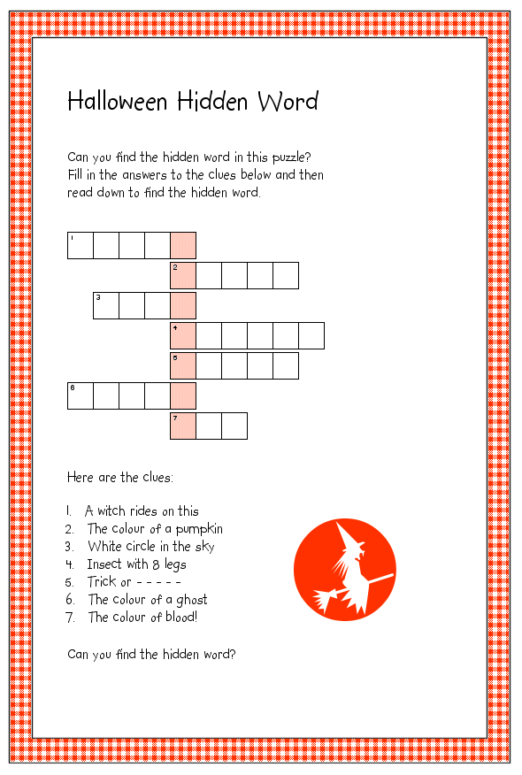
Відповіді: 1– a broom, 2 – orange, 3 – the moon, 4 – a spider, 5 – treat, 6 – white, 7 – red
Закодоване слово – a monster.

(Слайд 11)

ІІІ. The third task is named “Pathfinder”. You must help two spooky ghosts to find the path between them.
(Слайд 12)

IV. It wasn’t so difficult task, was it? And now you will be the Ghost Busters. You must find as many pictures of ghosts as possible (заздалегідь заховати в класі 10 забражень привидів. Команда, яка знайде більшу кількість зображень, перемагає). And now we have a team which gets one more point.
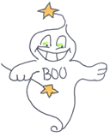
V. Your next mission is named “Collect the Skeleton”. You must collect the skeleton faster than your opponents. Each team throws the dice to get the number. If you have 6 – you get the skull, if you have 5 – body , if you have 3 or 4 – you get the leg and if you have 1 or 2 – you will get arm. If you have the same part of the skeleton, you miss your turn.
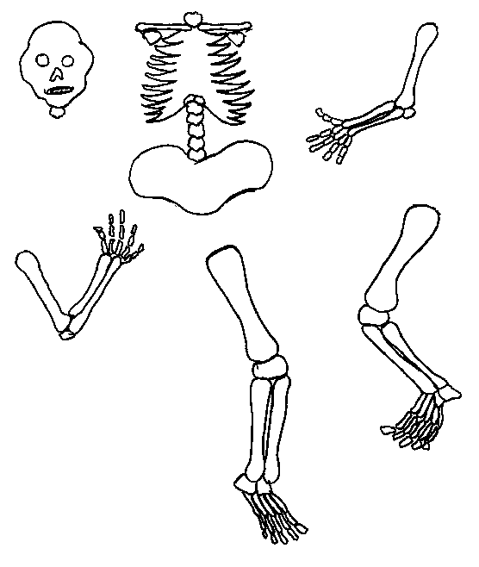
(Слайд 13)

VI. Well done. Next competition is “Halloween Word Searcher” – you must find all the scrambled words.
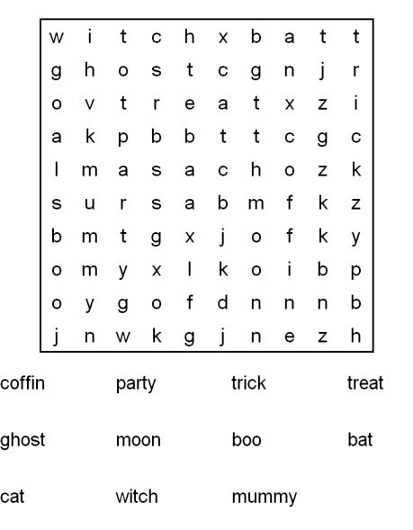

(Слайд 14)

VII. Can you count different things? Do you know the numbers? Let’s check it. You need to circle the right number of witches, skeletons, cats, etc.
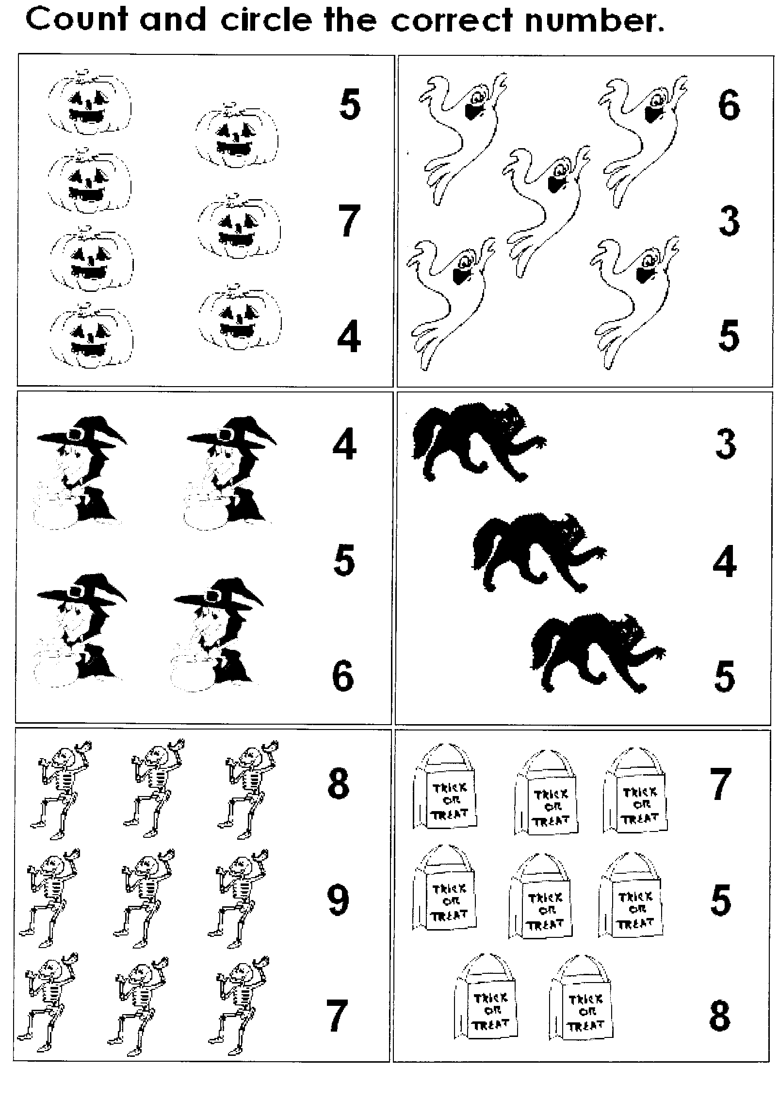
(Слайд 15)

VIII. You’ve got telegrams. They seem strange. Can you find out what they say?

Alittlewitchandahorribleskullappeared.

Awhiteghostandagreenmonsterfollowme.

(Слайди 16-21)

IX. This puzzle is for you.
1. When is Halloween celebrated?
a) December 25-th
b) February 14-th
c) October 31-st
2. What colors are associated with Halloween?
a) Red and green
b) Orange and black
c) Yellow and blue
3. Who can walk through the walls?
a) Witches
b) Goblins
c) Ghosts
4. What is worn around the neck to keep vampires away?
a) Garlic
b) Onion
c) Pepper
5. How many bones are there in the human skeleton?
a) About 50
b) Over 200
c) Over 1000
6. What does a witch use for transport?
a) A hat
b) A broomstick
c) A motorbike

(Слайд 22)

X. Well done. Next task is to put the sentences the right order to find out how to make a Jack o`Lantern.

Put the candle inside the pumpkin.
Cut a nose and a mouth.
Cut eyes.
Put the pumpkin near the house.
Take a big yellow pumpkin.
Light the candle.

(Слайди 23-28)

XI. These riddles are for you.
1. I flight at night because I don't like light (Bat)
2. I'm scary and white. I come out at night. Who am I? (Ghost)
3. I've got soft black fur. When you hold me I purr. Who am I? (Cat)
4. I'm round on all sides. I've got a light inside. Who am I? (Jack-o-lantern)
5. I've got a black cat and a big pointed hat. Who am I? (Witch)
6. I’m yellow or white. I smile on Halloween night. Who am I? (Moon)

And now let’s play games. (You can find Halloween games here http://www.scholastic.com/teachers/collection/halloween-activity-set)

Підведення підсумків конкурсу, нагородження.

(Слайд 29)

Well. I thank you all the participants for taking part in this lesson. You were very nice, clever and cheerful.

